Project: No Empty Plate
Team Ethos
Sheikh Sabah Ali, Yu-chen Chung

Keywords: Low-income household, food inequality, grocery equity, food affordability, price stability, decision support system, nutrition access

Abstract
Inflation and price instability make it harder for low-income families to afford nutritious groceries, forcing them to buy lower-quality alternatives or skip essential items. Ethos proposes a Grocery Equity Support System that helps families quickly access information about grocery stores or neighborhoods based on affordability, nutritional value, accessibility and price volatility. The system identifies stores that consistently support equitable food access even during inflation or supply shortage while maintaining adequate nutritional standards. This system also highlights neighborhoods where grocery access remains reliable, within reasonable budget and transportation constraints. This system shall allow families to compare nearby grocery options, track price trends and make purchasing decisions within budget and transportation limits, which helps reduce systematic inequities in food access.
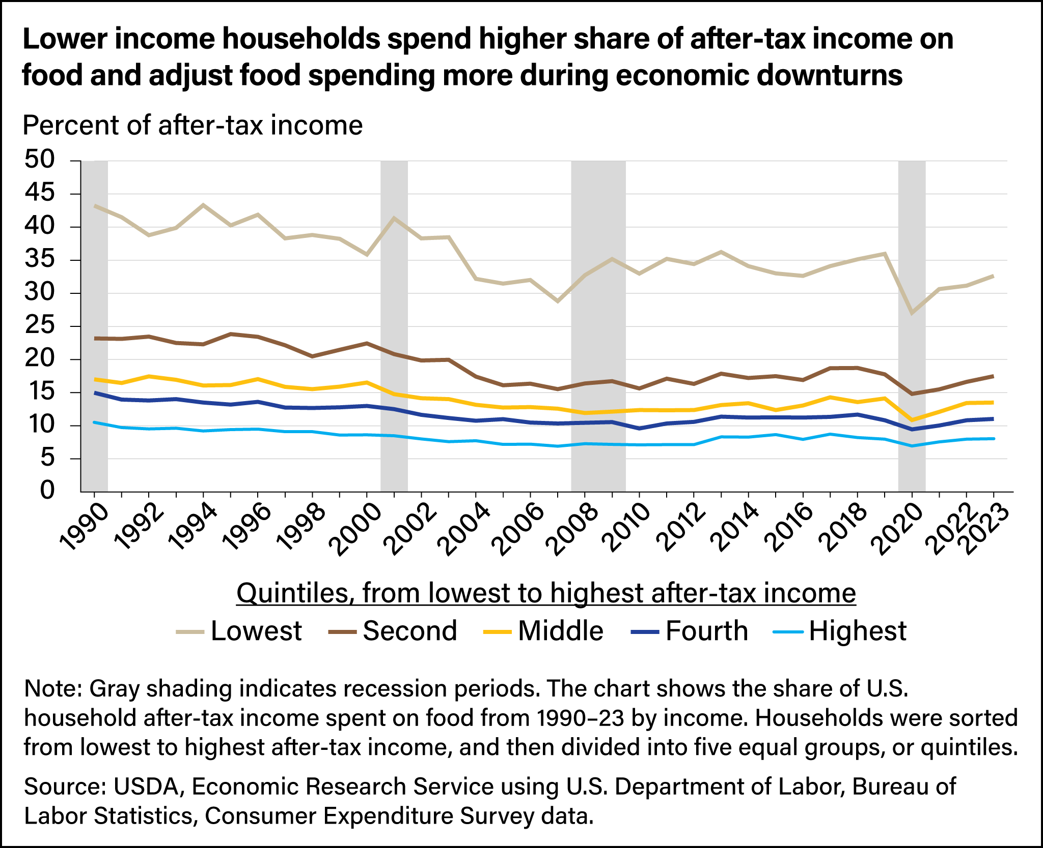
Problem Statement
Since January 2020, food prices in the U.S. have risen uncontrollably and overall grocery prices went up about 28.3% before mid-2025 compared with pre-pandemic levels [1]. In 2025, families have paid approximately $310 more on groceries compared with 2024 for essential items, such as milk, chicken, bananas, etc [2]. This price instability is causing low-income families to be forced into less nutritious or lower-quality grocery options. Polls show that about 90% of American adults report that rising prices for healthy food are making it harder to eat well [3]. These systematic issues limit choices, worsen nutrition inequality and make it difficult for families to consistently afford essential groceries. Low-income households spend a much larger part of their income on food. For example, in 2023, these households had spent 32.6% of after-tax income on food, compared to 8.1% for higher income households [4]. These trends illustrate how economic pressure and uneven food access can turn into systemic barriers, leaving low-income families with fewer viable options for maintaining consistent and nutritious diets.

Motivation
Poor nutrition often goes unnoticed at first since families may prioritize affordability over healthy options. Over time, this habit can gradually increase the chance of chronic disease and negatively affect overall well-being, especially within low-income households [5] . As for the work life, it also reduces cognitive function and work performance, increasing the risk of mistakes, absenteeism, and long-term economic instability [6]. Constant bad diet or fatigue from skipping meals can decrease work motivation, which can lead to job loss and financial hardship. On a community level, it may increase homelessness and crime. Making a Grocery Equity Support System is not just beneficial for low income households, it could also help keep the natural harmony of American communities.
Solution
We propose an app that displays an “Equity Score” for nearby grocery stores or neighborhoods of the user. The score is between the range of 0 and 10, with 0 being least affordable and 10 being most affordable.The score is calculated using different factors, such as affordability, nutrition access, physical accessibility, and price volatility. Each of these sub-categories will also have their own scale between 0 to 10. For neighborhoods, the system will ideally account for all the grocery stores located within and their average Equity Score will be given as the score for the neighborhood. Users can also compare stores or neighborhoods side-by-side to choose the most equitable option. By giving this information in a clear and accessible manner, the system allows low-income families to quickly identify which grocery options would best support their budget, access and nutritional needs.
Pre-existing innovations
USDA Food Access Research Atlas - an interactive mapping tool that shows grocery store accessibility across different areas based on income level and distance to supermarkets. It helps identify low-access and low-low income locations using census data [7].
How No Empty Plate Does it Different - The USDA Atlas tools are great for researchers and policymakers, but it’s not usable for everyday families and are not widely known among the general public. This project focuses on turning these complex food access data into a simple, user-friendly system that helps households directly compare nearby grocery options based on affordability, nutrition access and accessibility.
Nehren - Grocery Price search and Comparison - a mobile and web-based application that allows users to compare prices for grocery items across multiple stores. It gives smart shopping lists and real-time price updates, which helps users identify the cheapest store for each product and plan purchases to save money [8].
How No Empty Plate Does It Different - While Nahren focuses on item-level pricing and short-term savings, it doesn’t take nutrition quality, neighborhood-level access, transportation constraints or price volatility over time into consideration. This project differs by taking all these into consideration and turning them into a single score for stores and neighborhoods. This gives actionable, long-term decision support specifically for low-income households.
Conclusion for ‘Pre-Existing Innovations’ - Although there are existing web and mobile apps that provide some service similar to this project, no single app combines affordability, nutrition, accessibility and neighborhood equity the way this project shall do.

Citation (draft)
[1] https://www.pewresearch.org/short-reads/2025/05/15/5-facts-about-food-costs-in-america/
[2]
https://www.allrecipes.com/joint-economic-committee-grocery-bill-study-2025-11885184
[3]
https://www.cnn.com/2025/05/07/health/higher-food-prices-pew-survey-wellness
[4] [Image Source]
https://ers.usda.gov/amber-waves/2025/june/food-price-inflation-slowed-in-2023-and-2024
[5]
https://www.ilo.org/publications/food-work-workplace-solutions-malnutrition-obesity-and-chronic-diseases
[6]
https://www.ilo.org/resource/news/poor-workplace-nutrition-hits-workers-health-and-productivity-says-new-ilo
[7]
https://www.ers.usda.gov/data-products/food-access-research-atlas
[8]
https://apps.apple.com/us/app/nahren-grocery-price-finder/id6744700568 s

